EXPERIMENT 1:

Develpe AND Design a Mobile or Web application to change back ground color and menu.

AIM:

To Devolpe and Design a Mobile app to Change background colour and menu.

PROCEDURE:

\*CREATE A WIREFRAME ACCORDIND TO YOUR DESIGN.

\*SELECT THE THEME FOR YOUR DESIGN.

\*USE PLUGINS LIKE ICONFIY AND UNSPLASH TO INSERT ICONS AND PHOTOS TO YOUR DESIGN.

\*THE DESIGN OF YOUR APPLICATION IS READY.

BEFORE:

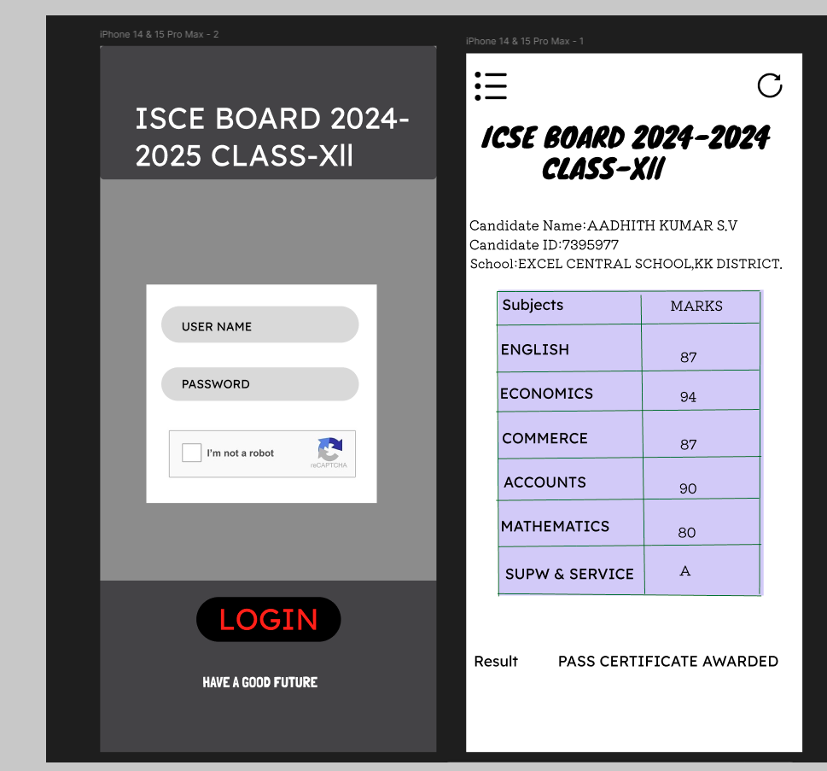

AFTER: 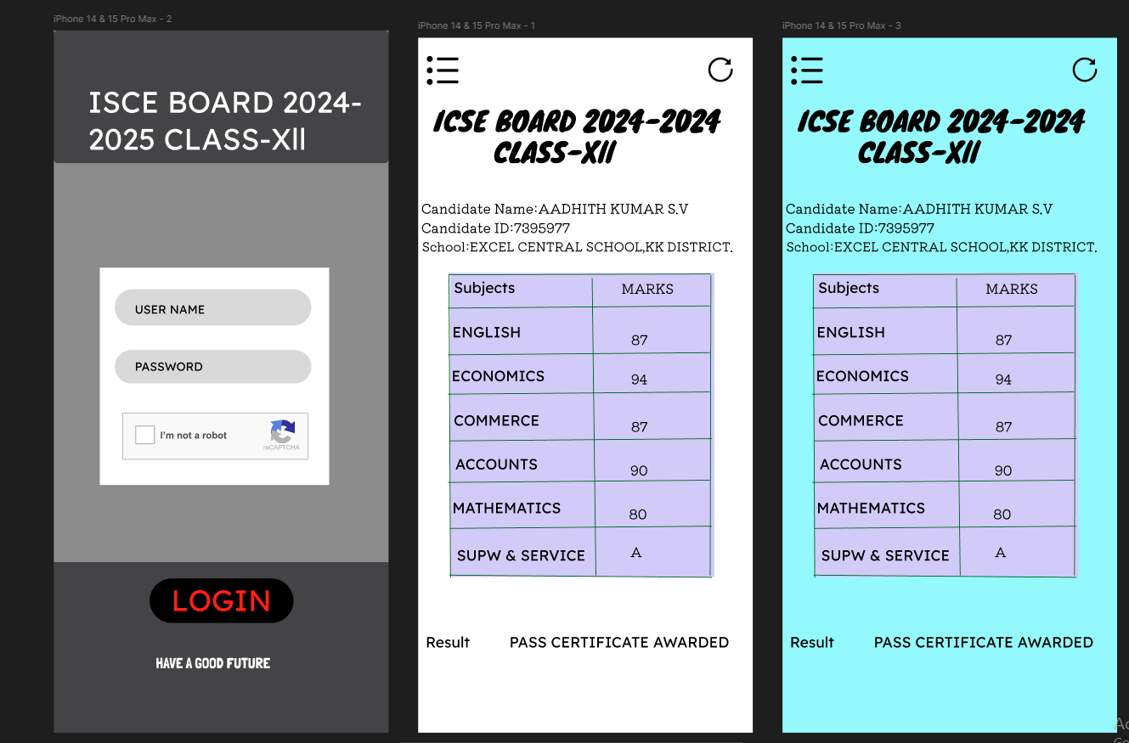

RESULT: DESIGNING A MOBILE APPLICATION IS UCCESSFULLY DEVELOPED.